

Application Ref. | PA/2025/1815
Location | 1 Nelson Avenue, ECCLES, MANCHESTER, M30 9GB
Ward | Eccles Ward
Applicant | Molly Pipping
Proposal | Proposed single storey side/ rear infill extension
Recommendation | Approve with Conditions

Location Plan
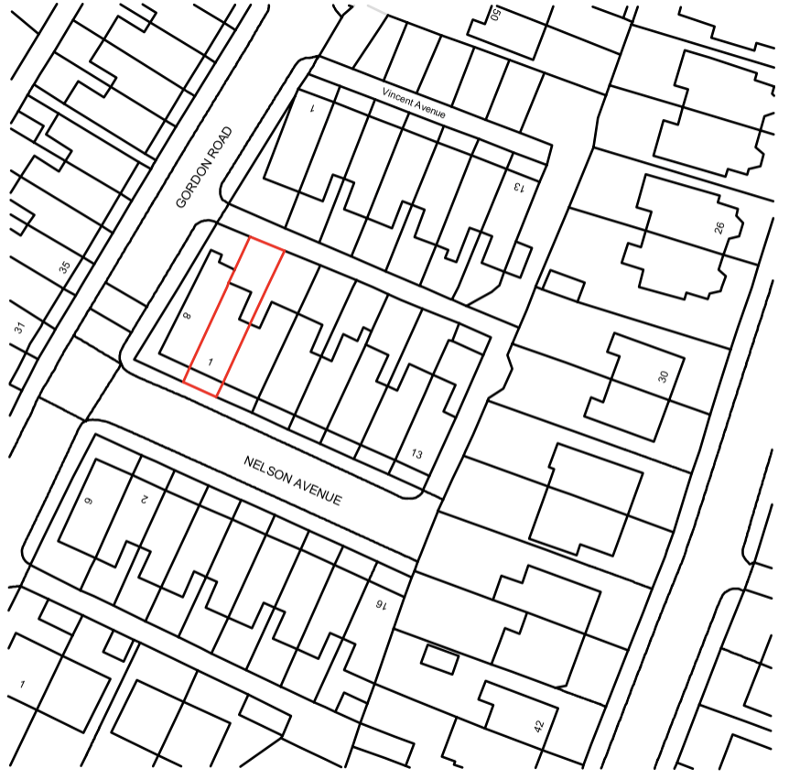
Description of Site and Surrounding Area

The application relates to a two storey mid-terrace dwelling located on the north side of Nelson Avenue in Eccles. The dwelling is faced in brick beneath a pitched roof, and includes a two storey outrigger to the rear.
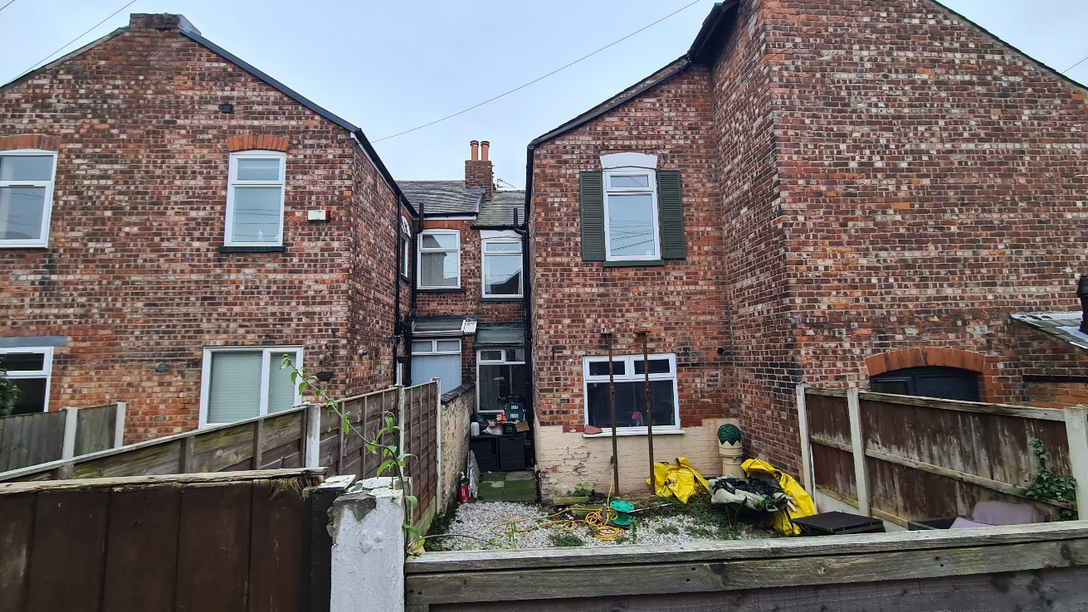
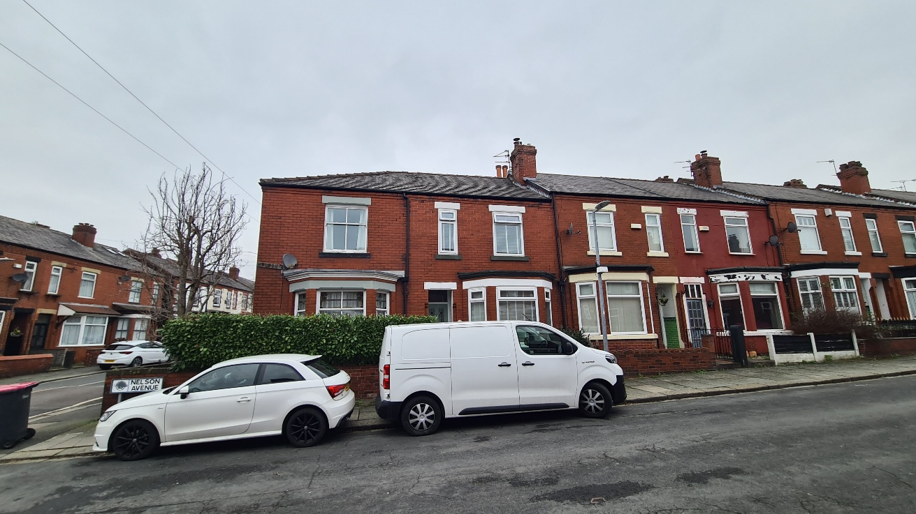
Description of Proposal

Planning permission is sought for the erection of a single storey side extension to provide additional living accommodation for the applicant in the form of an expanded kitchen / dining room.

The extension would be faced in brick to match and sit beneath a pitched roof. It would abut the shared boundary with the adjoining neighbour and sit flush with the existing rear elevation. The existing opening to the rear within the outrigger would be replaced with a new window across the extended rear elevation.
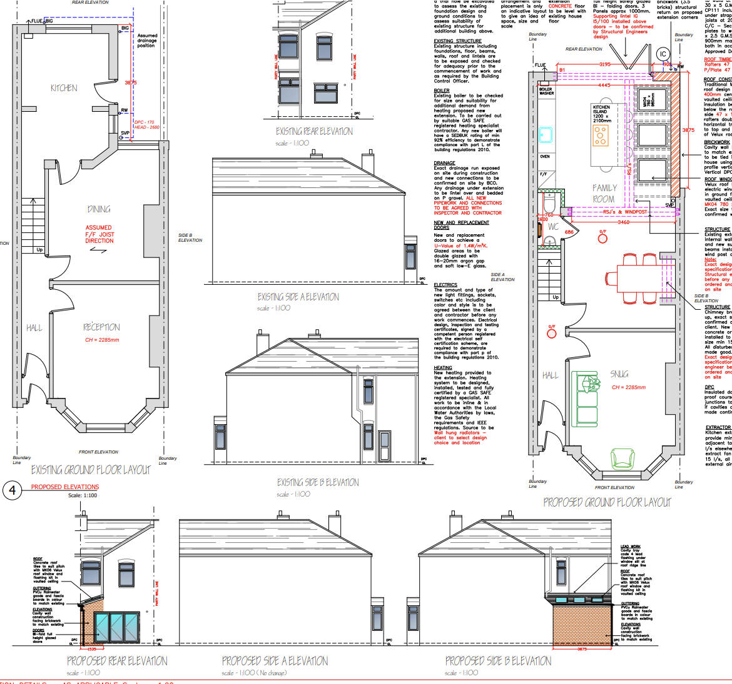

Relevant Planning History
None

Publicity
Neighbours - Publicity Start Date - 9 January 2026
Neighbour Notification
Below is a summary of the comments that have been received on this application. The key material planning considerations are discussed within the appraisal section of this report.
The number of neighbouring properties notified - 5
Representations from neighbours and members of the public
None

Consultations

N/A

Planning Policy
Salford Local Plan: Development Management Policies and Designations (SLP:DMP)
Policy D1 Design principles
Policy D2 Local character and distinctiveness
Policy D3 Layout and access
Policy D5 Amenity
Policy D8 Alterations and extensions

Other Material Planning Considerations
National
- National Planning Policy Framework
- National Planning Practice Guidance

Local Planning Policy and Development Framework/ Strategies
- Supplementary Planning Document – House Extensions (2006)

Local Finance Considerations
It is not considered that there are any local finance considerations that are material to the application.

Appraisal
Impact on the Character of the Area
- The extension would be largely hidden from public views – minimising its effect on the street scene.

- Facing materials are to match (with the exception of window surrounds and roof tiles), which together window placement and overall scale of the extension, it is considered largely proportionate and sympathetic to the parent dwelling and character of the area.

- It is not considered that the development would have a detrimental impact on the character and appearance of the surrounding area as per Policies D1, D2 and D8 of the SLP:DMP

Impact on the Amenity of Neighbours
- The proposed extension would introduce new openings to the rear (east) serving a kitchen / dining room – considered a habitable room for the purposes of the assessment. The window would be approximately 6.8m from the rear boundary of the site which is considered acceptable in accordance with Policy HE2 of the SPD.

- It would be approximately 14.6m from the rear facing windows (serving habitable rooms) of the neighbour to the rear, no. 3 Vincent Avenue. Whilst below the 21m set out within Policies HE1 of the SPD and D5 of the SLP:DMP, it is acknowledged that the distance would be no greater than the existing given that the proposed window would replace the existing window within the outrigger. In addition, views would be obscured by the existing boundary walls, so the proposal is not considered to have any greater impact on the amenity / privacy of this neighbour than the existing situation.

- The extension would project 3.875m along the common boundary with the adjoining neighbour, no. 3 Nelson Avenue. The two storey outriggers to these properties already create a restricted outlook (akin to a tunnelling effect) from rear facing windows of these houses. The extension would project 0.875m beyond a point drawn at a 45 degree angle 3m along the boundary with this neighbour, contrary to Policy HE5 of the SPD. It is however acknowledged that the extension would project no further than the existing outrigger which together with its single storey nature and pitched roof, is not considered to pose a severe risk to the neighbours outlook. Noting as well the orientation of the terrace, the extension would not cause any additional overshadowing or block sunlight to this neighbours rear windows. Altogether, the impact on this neighbour is not considered to result in an amount of harm to the amenity of this neighbour as would warrant a reason to refuse planning permission.

- The extension would not be visible to the adjoining neighbour to the west, no. 8 Gordon Road which itself projects further to the rear than the application property.

- The proposed roof lights are not considered to pose a risk to any neighbours amenity or privacy.

- Taking into consideration the above, the development’s impact on the amenity of neighbours is, on balance, considered acceptable and compliant with Policy D5 of the SLP:DMP and the SPD.

Other Issues
Does the proposal require works to trees?
No
Is there a significant change in levels across the site or between the site and neighbouring land?
No
Has the applicant/agent indicated any personal circumstances?
No

Recommendation
Approve with Conditions

Document Approval
Report Author | Aslan Saylam
Date | 09.02.2026
Reviewer | M Hodgson
Date | 09.02.2026

