

Application Ref. | PA/2025/1608
Location | 2 Crossfield Drive, SWINTON, MANCHESTER, M27 9TN
Ward | Swinton and Wardley Ward
Applicant | Mr Shaun Whitehead
Proposal | Demolition of pre-cast garage and erection of a part two / part single storey side extension
Recommendation | Approve with Conditions

Location Plan
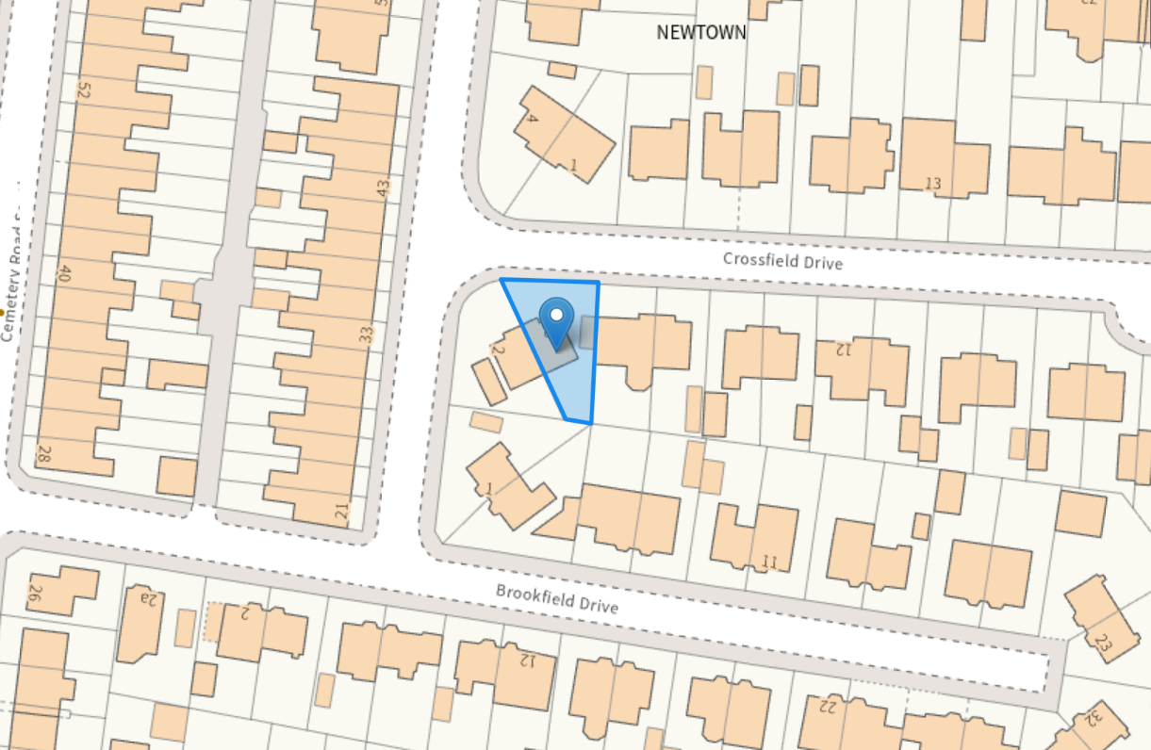

Description of Site and Surrounding Area
The site is a two-storey semi-detached property in the mainly residential area of Swinton. It has a moderately sized front garden and main private amenity space to the rear. There is an existing garage along the eastern boundary.

Description of Proposal
Planning permission is sought for:
Demolition of existing garage: 4m long by 2.4m wide
Erection of a part single storey side extension:1.8m wide at its widest, 3.9m deep, 2.7m tall from ground level to the eaves, 4.4m tall from ground level to where the ridge meets the main building.
Erection of a part two storey side extension: 6.1m deep, 2.6m wide, 5.2m tall from ground level to the eaves, 7.2m from ground level to the ridge.

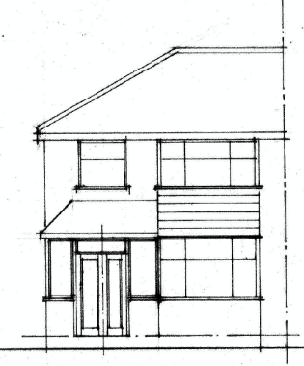  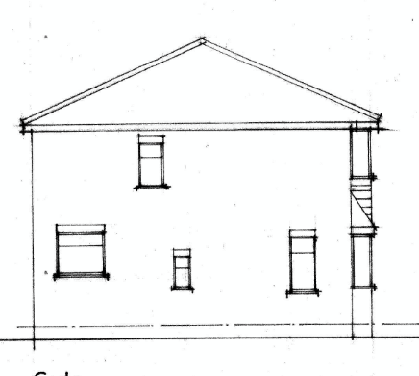 | 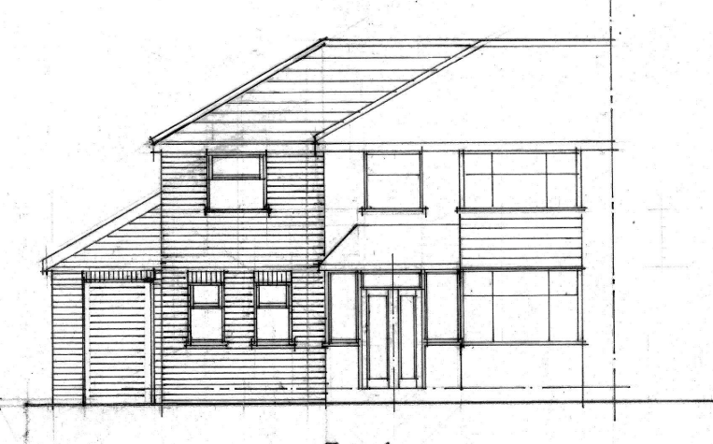  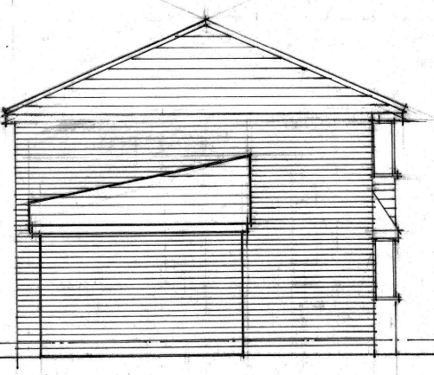
Existing front (South) and left (East) elevation | Proposed front (south) and left (east) elevation
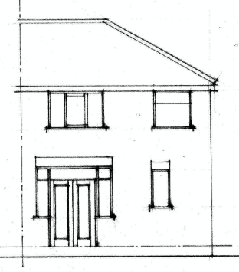 | 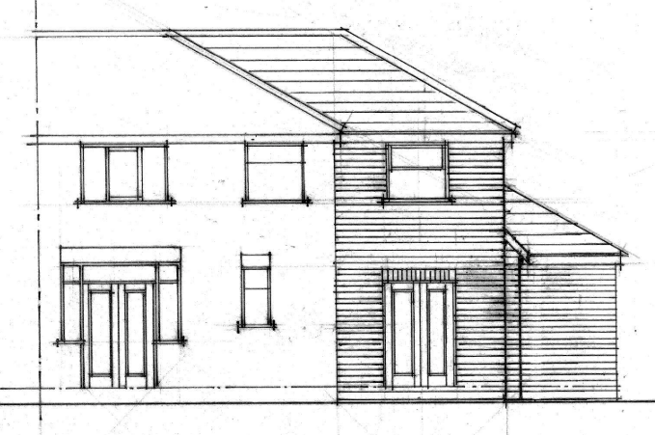
Existing rear (South) | Proposed rear (south)
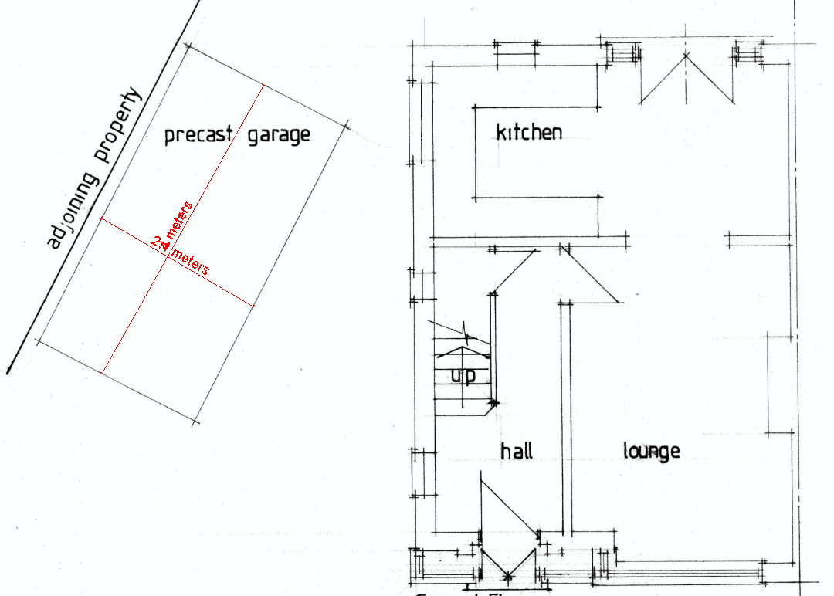  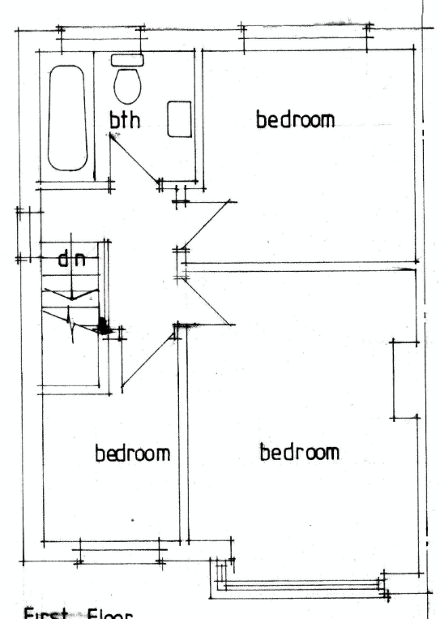 | 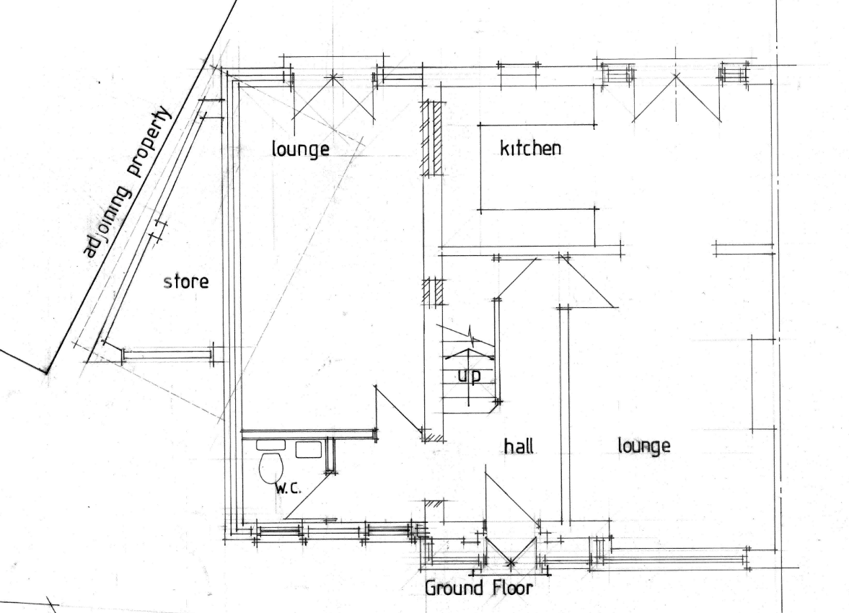  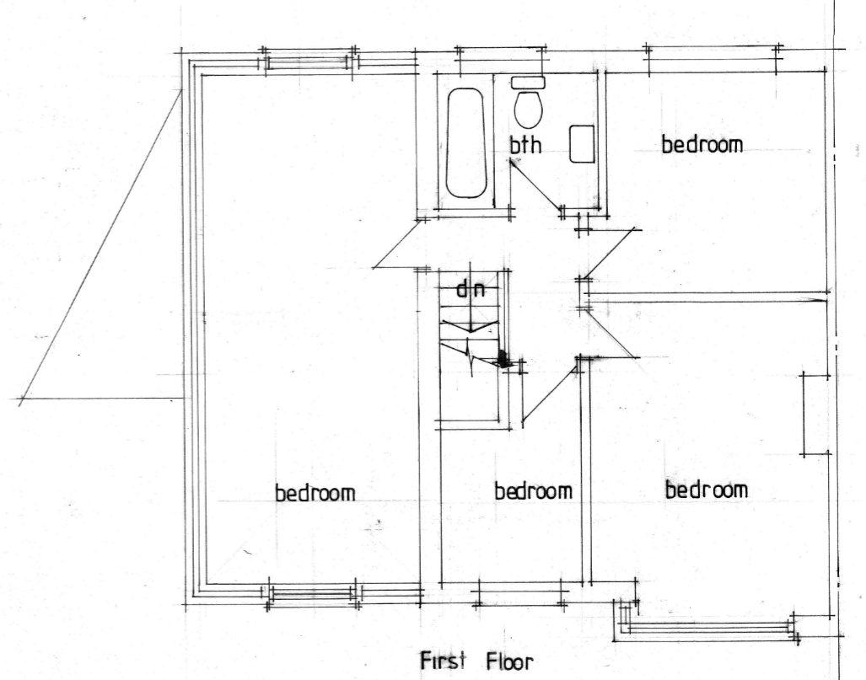
Existing ground floor and first floor plan | Proposed ground floor and first floor plan
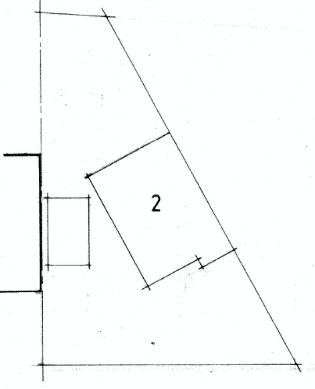 | 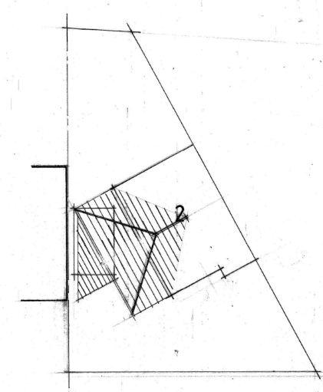
Existing site plan | Proposed site plan

Relevant Planning History
Planning Applications
None relevant

Publicity
Neighbours - Publicity Start Date - 25 November 2025

Neighbour Notification
Neighbouring properties have been notified of the application via letter. Representations that have been received, are detailed as below.
The number of neighbouring properties notified - 8
Representations from neighbours and members of the public
Comments of Support - 0
Comments of Objection - 1
Other Representations – 0

 | C= Objector’s comments | R= Officer’s response
C | Concerns have been raised about the scale of the proposed extension, stating it will cause prolonged disruption, noise, dust, and potential damage to neighbouring property, with no clear measures for protection or repair. They highlight issues with access and parking during construction, noting that Crossfield Drive is a cul-de-sac with limited space, and anticipate increased congestion both during and after the works. The objection also raises concerns about inaccurate documentation within the application, specifically energy and carbon statements referring to a different property, which they believe must be corrected before determination. Additionally, they dispute the claim that there are no nearby trees, pointing out large trees in adjacent gardens that could affect the development. Overall, they fear the proposal will negatively impact the neighbourhood.
R | There may be some noise and disturbance during any construction period, this would be temporary and would not be a reason to refuse planning permission. Concerns around how construction might impact neighbours should be raised with the applicant and contractors. Issues around highways and parking will be addressed in the appraisal below. The energy and carbon statement was attached to this application in error. There is not a requirement for an application of this nature to submit an energy and carbon statement. This has been rectified. The large trees in neighbouring gardens are a sufficient distance from the proposed development such that the development would not be expected to result in any unacceptable impact to them.

Planning Policy
Salford Local Plan: Development Management Policies and Designations (SLP:DMP)
Policy A6 Highway network
Policy D1 Design principles
Policy D2 Local character and distinctiveness
Policy D3 Layout and access
Policy D5 Amenity
Policy D8 Alterations and extensions

Other Material Planning Considerations
National
- National Planning Policy Framework
- National Planning Practice Guidance

Local Planning Policy and Development Framework/ Strategies
- Supplementary Planning Document – House Extensions (2006)

Local Finance Considerations
It is not considered that there are any local finance considerations that are material to the application.

Appraisal
Impact on the Character of the Area
- The dwelling sits on a modest plot with a small front garden which includes a driveway accessing the garage. The main private amenity space is to the rear of the property. The proposed works will replace the existing garage at the side of the property.
- The existing garage is visible from the existing street scene. It is not uncommon for a house in this area to have a detached flat roof garage but this isn’t established as a characteristic of the properties in the area. Development would involve demolition of the garage and this would be replaced with the extension of the existing dwelling. This will be of an improved visual appearance and likely to have a positive impact on the character of the area.
- The part single storey side extension would add storage space to the property, it is to be built along the shared boundary with No. 4 Crossfield Drive, and although visible from the street scene it will be behind the building line of the existing buildings and not likely to have an impact on the street scene.
- The part two storey side extension will be highly visible from the street scene. It is proportionate in scale and mass. It will extend the principal elevation approximately 2.7m further than the neighbouring property and at its corner will sit forward of the existing building line (albeit it is noted that the properties on the south side of Crossfield Drive have a staggered siting and therefore there is not a consistent and well established building line in this regard).
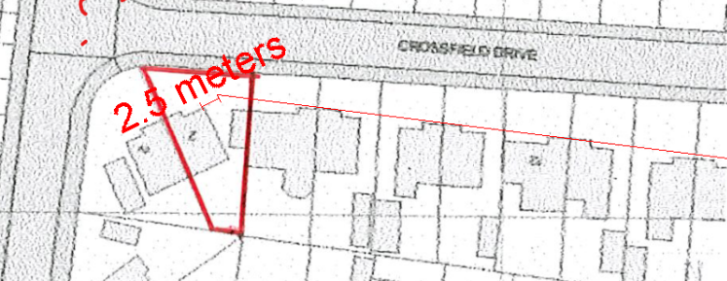 | 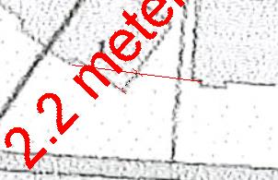
Existing building line extending down Crossfield drive and location of two-storey extension. | Relationship between the opposite neighbour at No. 1 Crossfield drive and the building line to the end of Crossfield drive.

- The originally submitted design included a gable end to the two storey side extension which would have exacerbated the visual prominence of the extension having regard to the building line and rhythm of the street. After highlighting these issues with the agent, amended plans were received that feature a hipped end which is more subservient and in keeping with the existing roof form of the host dwelling and its neighbours.
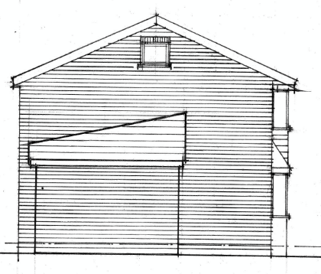  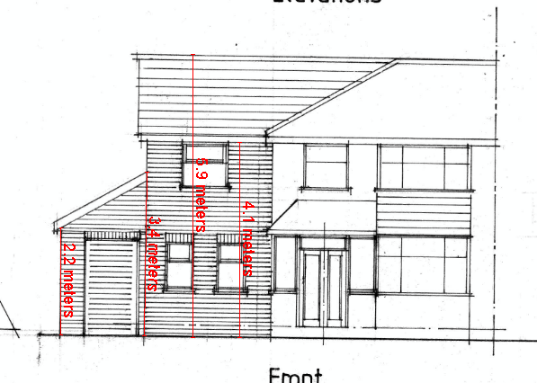 | 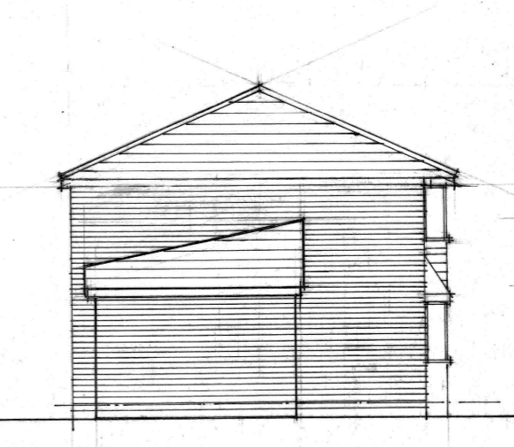
Originally proposed plans | Amended plans

- Given the position of the application property at the entrance to the cul‑de‑sac, the angled arrangement of the existing building line, the minor visual disruption caused by the projection of the extension is considered acceptable. The extension will also be constructed using materials that match those of the existing dwelling.
- The rear elevation of the proposed side extension would be positioned approximately 0.5m from the side boundary shared with No.4 at its closest point; however, there would be a separation of over 2 m between this shared boundary and the front elevation of the two storey side extension and No.4 is set at an offset angle to the host dwelling. Given these factors, the proposal is not considered to result in a potential terracing effect and ensures compliance with HE8.
- The proposed works will still allow off street parking for one car.
- Given the context of the surrounding area the development does not therefore cause any unacceptable harm to the character of the area, in accordance with Policies D1, D2 and D8 of the SLP:DMP, the House Extensions SPD and NPPF.

Impact on the Amenity of Neighbours
- The adjoining neighbour to the west, No. 2 Normanby Street will not be affected by the proposed development which will be sited on the east side of the application property.
- The adjacent neighbour to the east (No. 4) will have the single storey side element of the extension being built in close proximity to the shared boundary. This will replace the existing detached garage. It will be similar in size but taller due to the pitched roof. It is built next to a blank gable end, behind the principal elevation and so will not have a noticeable negative effect on any windows. The two-storey side element would also be adjacent to this neighbour and protrude approximately 2.7m beyond their principal elevation with a separation distance of 2.9m. The host property is angled away from the neighbour and the extension would follow that line. Considering these factors, the proposal would not result in any overbearing impact on any of the windows within No.4’s front elevation.
- The proposal includes two habitable room windows in the rear elevation, facing towards the garden of No. 4. Owing to the 2 m boundary fence and the slight difference in land levels, the ground‑floor window is unlikely to result in any harmful overlooking. However, due to the angle of the site and the distance to the boundary, the proposed first floor bedroom window could give rise to overlooking. As the bedroom would have a dual aspect, the rear facing window could be obscure glazed to protect the neighbour’s amenity without adversely affecting the applicant’s living conditions. This would be secured via condition on any grant of consent.
- Given the location of the development and the orientation of the sun in relation to No.4, the development would not introduce harm to neighbouring residential amenity with regards to overshadowing.
- For the properties to the south, No. 1 Normanby Street and Nos. 3 and 5 Brookfield Drive, the two‑storey side extension would sit at an obtuse angle and would be visible from the rear. The proposed ground floor window would be obscured by boundary treatment and the first floor window would be no closer to these neighbouring properties than the existing habitable room windows. Given the current relationship between the dwellings, the angle of their orientation, and the separation provided by the gardens, the development is unlikely to introduce significant harm with regards to overlooking, overbearing or overshadowing.
- Opposite to the north is No. 1 Crossfield Drive, the proposed works will maintain a separation distance of 19m. They are separated by two front gardens and a highway. It is not considered that there will be an unacceptable negative effect on the amenity of this neighbour.
- Given the context of the surrounding area the development does not therefore cause any unacceptable harm to the amenity of the users and amenity or privacy of the neighbouring users and is in line with Policy D5 of the SLP:DMP, the House Extensions SPD and the NPPF.

Impact on the Highway Network
- The number of bedrooms will increase from three to four. This increase is not considered to be significant to increase the provisions required for parking. The proposed works will not result in a loss of off-street parking, and the property is within a sustainable location with links to public transport.

Other Issues
Does the proposal require works to trees?
No
Is there a significant change in levels across the site or between the site and neighbouring land?
No
Has the applicant/agent indicated any personal circumstances?
No

Recommendation
Approve with Conditions

Document Approval
Report Author | Andrew Borg-Fenech
Date | 10/02/2026
Reviewer | Jade Corcoran
Date | 10/02/2026

