

Application Ref. | PA/2026/0020
Location | 11 Back Hulme Street, Salford, M5 4RH
Ward | Ordsall Ward
Applicant | c/o agent
Proposal | Application for a lawful development certificate for remedial works comprising the installation of aluminium capping to parapets and other minor waterproofing works for the purposes of building maintenance.
Recommendation | Approve

Location Plan

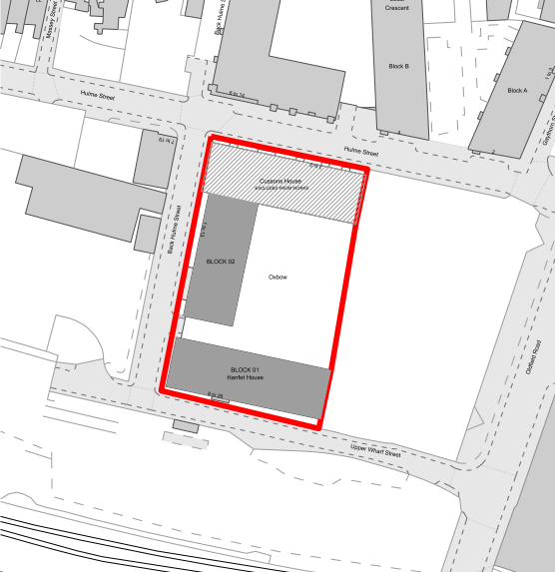

Description of Site and Surrounding Area

The application site comprises a Build to Rent residential development known as Oxbow, constructed pursuant to planning permission granted in March 2016.

The wider development consists of three blocks ranging in height from 6 to 18 storeys. Blocks 01 and 02, located along Upper Wharf Street and Back Hulme Street respectively, form the subject of the current application.

The site does not lie within a conservation area and contains no statutorily listed buildings. It lies within the extent of an Article 4 Direction removing permitted development rights for changes of use from dwellinghouses to small Houses in Multiple Occupation; however, this relates solely to changes of use and does not restrict routine maintenance or minor external alterations to existing buildings. No other planning constraints or designations are considered material to the assessment of the proposed works.

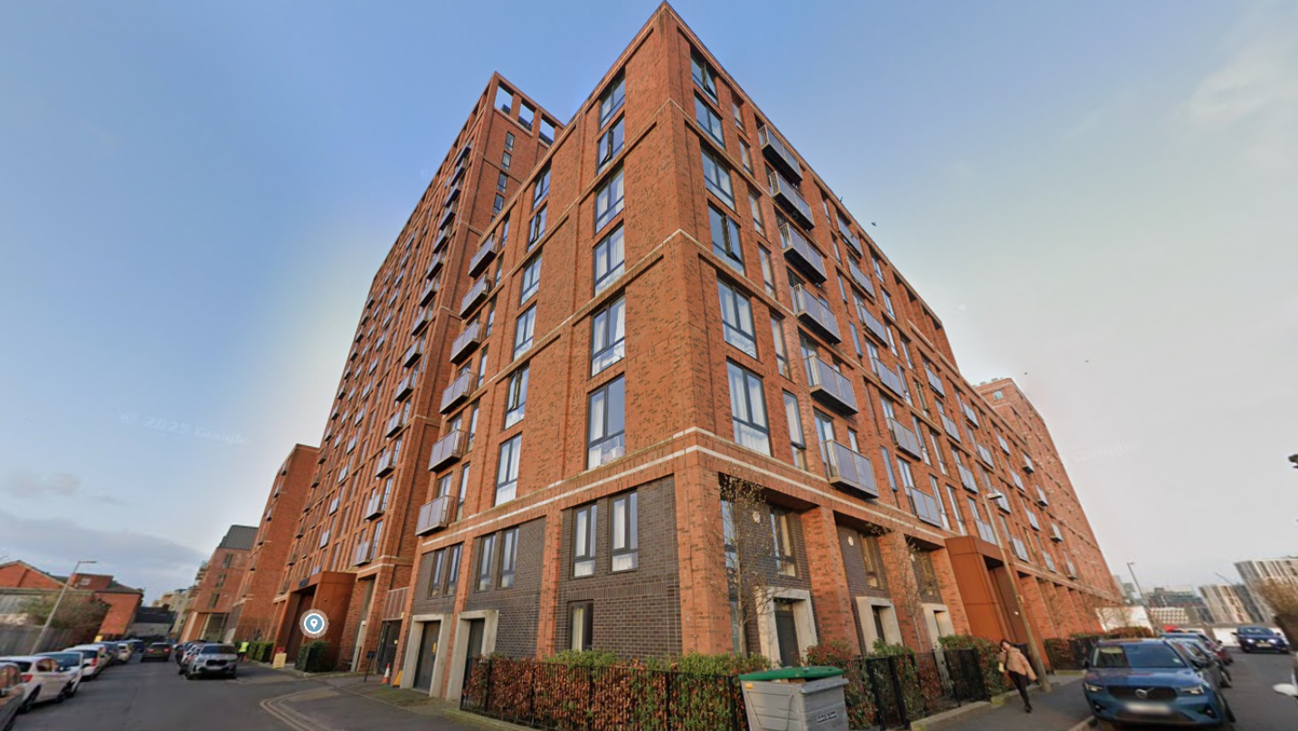

Description of Proposal

The purpose of the application is to obtain formal confirmation from the Local Planning Authority (LPA) that the works described below would not constitute development requiring planning permission under Section 55 of the Town and Country Planning Act 1990 (as amended).

The proposal relates to the carrying out of remedial works to address and resolve ongoing water ingress at roof level, which has resulted in damage to residential units within Blocks 01 and 02.

The works would comprise the installation of aluminium capping to the tops of the existing parapets, together with associated waterproofing measures.

The proposed aluminium capping would be fixed along the upper joint of the existing parapets and finished in a concrete-coloured coating to match the prevailing external finish of the building. The installation would increase the overall parapet height by no more than 60mm.

In addition, the works include the installation of a new waterproofing membrane to the inner face of the existing concrete upstands. This membrane, measuring approximately 75mm in width, would extend across the concrete surface and up the sides of inward-facing pillars in selected locations.

Flashing would then be applied to the internal faces of the columns to complete the waterproofing treatment.
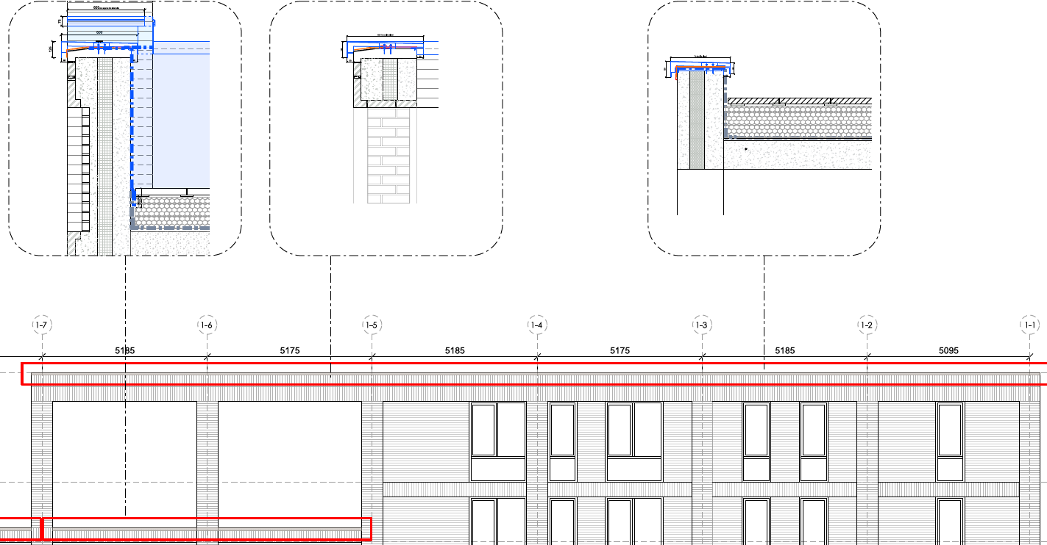
Extract 1: Proposed Remedial Works (Sections and Elevations)

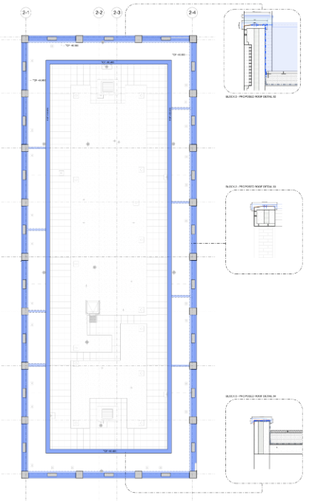
Extract 2: Extent of Remedial Works to Block 2
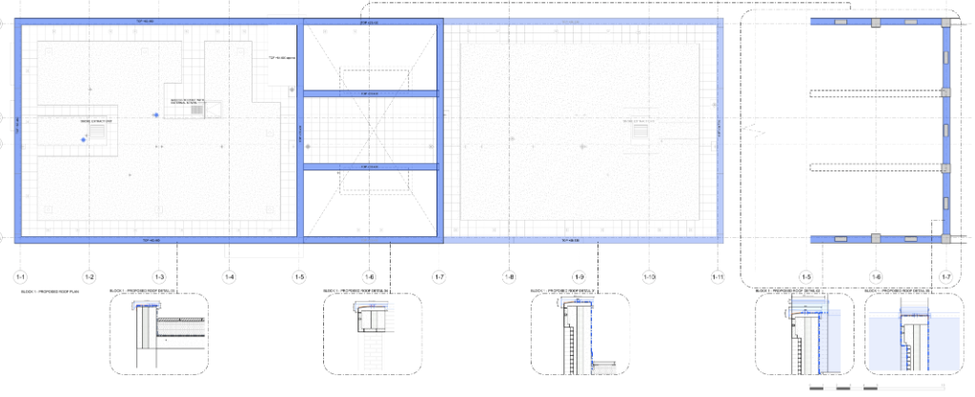
Extract 3: Extent of Remedial Works to Block 1

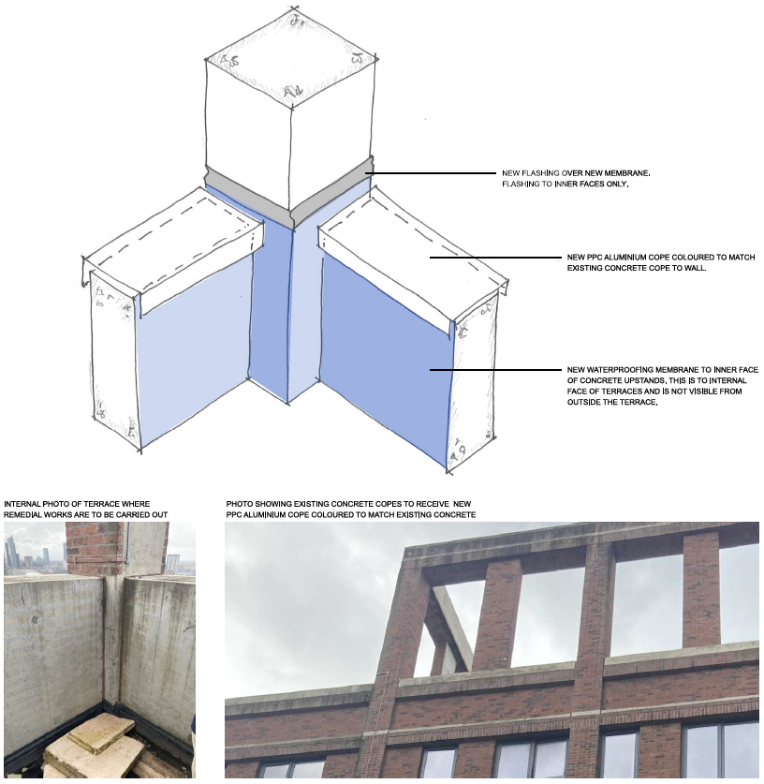
Extract 4: Diagram of Remedial Works

Relevant Planning History

19/74436/DISCON - Approval of details reserved by a condition
Decision: Condition Request determined - Sent: 8 January 2020
5 Hulme Street, Salford, M5 4PX
Request for confirmation of partial compliance of condition 12 (Verification Report) attached to planning permission 15/66823/OUT.

19/74125/DISCON - Approval of details reserved by a condition
Decision: Condition Request determined - Sent: 9 October 2019
5 Hulme Street, Salford, M5 4PX
Request for confirmation of compliance with Condition 11 (Cycle Parking) attached to planning permission 15/66823/OUT

19/73549/DISCON - Approval of details reserved by a condition
Decision: Condition Request determined - Sent: 29 July 2019
5 Hulme Street, Salford, M5 4PX
Request for confirmation of compliance of condition 8 (Travel Plan) 15/66823/OUT.
19/73183/NMA - Non-Material Amendment
Decision: Withdrawn - Sent: 25 March 2019
5 Hulme Street, Salford, M5 4PX
Application for a non-material amendment to planning permission 16/68405/REM to replace the previously approved drawing 50319_EL(90)02 revision B with revision D and landscaping changes.

19/72899/DISCON - Approval of details reserved by a condition
Decision: Condition Request determined - Sent: 27 February 2019
5 Hulme Street, Salford, M5 4PX
Request for confirmation of partial compliance of condition 5 (verification) attached to planning permission 15/66823/OUT.

18/72334/NMA - Non-Material Amendment
Decision: Approve - Sent: 14 September 2018
5 Hulme Street, Salford, M5 4PX
Application for a non-material amendment to planning permission 16/68405/REM for amending external finish of duplex apartments and removal of railings at level 17.
18/71438/NMA - Non-Material Amendment
Decision: Approve - Sent: 29 March 2018
5 Hulme Street, Salford, M5 4PX
APPLICATION FOR A NON-MATERIAL AMENDMENT TO PLANNING PERMISSION 16/68405/REM TO REVISE THE MATERIAL OF THE BALCONIES

18/72334/NMA - Non-Material Amendment
Decision: Approve - Sent: 14 September 2018
5 Hulme Street, Salford, M5 4PX
Application for a non-material amendment to planning permission 16/68405/REM for amending external finish of duplex apartments and removal of railings at level 17.

17/69898/DISCON - Approval of details reserved by a condition
Decision: Approve - Sent: 19 May 2017
5 Hulme Street, Salford, M5 4PX
Request for confirmation of compliance of condition 6 (surface water drainage) attached to planning permission 15/66823/OUT.

17/69585/DISCON - Approval of details reserved by a condition
Decision: Approve - Sent: 26 April 2017
5 Hulme Street, Salford, M5 4PX
Request for confirmation of compliance of conditions 5 (site investigation), 7 (noise), 10 (phasing), 12 (noise-cemex) attached to planning permission 15/66823/OUT

16/69265/NMA - Non-Material Amendment
Decision: Approve - Sent: 21 December 2016
5 Hulme Street, Salford, M5 4PX
Application for a non-material amendment to planning permission 15/66823/OUT to increase the number of dwellings from 246 to 263 (as a result of a small decrease in the size of dwellings allowing an additional one-bed apartment on a total of 17 floors in blocks 2 and 3)

16/68471/DISCON - Approval of details reserved by a condition
Decision: Condition Request determined - Sent: 5 August 2016
Henry Sutcliffe Ltd, 5 Hulme Street, Salford, M5 4PX
Request of confirmation of compliance of condition 4 - Construction method Statement attached to planning permission 15/66823/OUT

16/68405/REM - Approval of reserved matters
Decision: Approve - Sent: 12 October 2016
5 Hulme Street, Salford, M5 4PX
Application for the approval of reserved matters for the Appearance, Landscaping, in pursuant of planning permission 15/66823/OUT for the erection of three residential blocks of 6, 8 and 18 storey's to provide 246 no. residential units with associated car parking

15/66823/OUT - Outline
Decision: Approve - Sent: 24 March 2016
5 Hulme Street, Salford, M5 4PX
Outline application for the demolition of existing buildings; the erection of three residential blocks of 6, 8 and 18 storeys to provide 246 no. residential units with associated car parking and landscaping. Details of access, layout and scale submitted for approval with all other matters reserved.
Publicity

Not applicable.

Neighbour Notification

Not applicable.

Consultations

Not applicable.

Planning Policy

Town and Country Planning Act (1990)

Other Material Planning Considerations

National
- National Planning Policy Framework
- National Planning Practice Guidance

Appraisal

Legislative Requirements

This application seeks a Lawful Development Certificate (LDC) under Section 192 of the Town and Country Planning Act 1990 (as amended) to confirm that the proposed works are de minimis in scale and effect and therefore do not constitute “development” requiring planning permission.

The application has been submitted on the basis that the proposed operations are so limited in their physical extent that they would not materially affect the external appearance of the building or the character of the site, and as such fall outside the scope of development as defined by Section 55 of the Act. The applicant therefore seeks formal confirmation that planning permission is not required.

In assessing an application for a LDC, the LPA must consider only the facts of the case. Planning merits are not material considerations. The assessment is therefore limited to determining, on the balance of probability, whether the proposed works would be lawful if carried out exactly as described in the submitted plans and supporting information.

The applicant refers to Section 55(2)(a) of the Town and Country Planning Act 1990 (‘the Act’), which states:

“The following operations or uses of land shall not be taken for the purposes of this Act to involve development of the land:
(a) the carrying out for the maintenance, improvement or other alteration of any building of works which
(i) affect only the interior of the building, or
(ii) do not materially affect the external appearance of the building.”

Section 55 provides the statutory definition of “development” and, therefore, establishes when planning permission is required. Paragraph 2(a)(ii) makes clear that works which do not materially affect the external appearance of a building are not considered development.

The term “materially affect” has no statutory definition, but is linked to the significance of the change which is made to a building’s external appearance (NPPG Paragraph: 001 Reference ID: 13-001-20140306).

Assessment of Proposed Works

In assessing this application for a LDC, the key consideration is whether the proposed works constitute “development” under Section 55 of the Town and Country Planning Act 1990.

As set out in Section 55(2)(a)(ii), works carried out for the maintenance, improvement, or other alteration of a building that do not materially affect its external appearance are not considered development and therefore do not require planning permission.

The proposed works under this application comprise:
- The installation of aluminium capping to the tops of the existing parapets on Blocks 01 and 02;
- The introduction of a new waterproofing membrane to the inner faces of the concrete upstands, including flashing to internal-facing columns.

These interventions are remedial in nature, intended to address ongoing water ingress and the resulting damage to the internal and external fabric of the building. The works are limited in scale and carefully designed to integrate with the existing building fabric.

The aluminium capping would be installed along the top joint of the parapets and finished in a concrete-coloured coating to match the existing façade. The height increase of the parapets would not exceed 60mm, a very minor alteration relative to the overall scale of the buildings, which range from 6 to 18 storeys. Given the small increase in height and the use of corresponding finishes, the visual impact of this element is negligible and would not materially alter the building’s external appearance.

The installation of the waterproofing membrane to the inner faces of the upstands, together with the application of flashing to the internal-facing pillars, is largely concealed from public view and would have no discernible impact on the external appearance of the building.
When considered in the context of the wider Oxbow development, which comprises three substantial residential blocks sitting alongside other high-rise buildings, the proposed works are minor and de minimis in scale and effect. Whilst new materiality would be introduced, it has been carefully selected to complement the existing appearance of the parapet areas and maintain visual consistency. They are also limited to specific roof-level elements whereby such interventions are consistent with routine maintenance and remedial works commonly undertaken to preserve the long-term structural and functional integrity of buildings.

In accordance with Section 55(2)(a)(ii) of the Act, the proposal represents the carrying out of essential maintenance whereby the remedial works would not materially affect the external appearance of the building. As such, they do not constitute development requiring planning permission.

Summary and Conclusion

In accordance with Section 55(2)(a)(ii) of the Act, the proposal represents the carrying out of essential maintenance whereby the remedial works would not materially affect the external appearance of the building. As such, they do not constitute development requiring planning permission.

The LPA is therefore satisfied that, if carried out as described in the submitted plans and supporting information detailed below, the works are lawful for planning purposes.

Drawing Reference | Drawing Number | Revision
Location Plan | 25089-56T-00-00S-D-A-001 | P02
Site Plan | 25089-56T-00-00S-D-A-002 | P02
Block 1 Roof Plan | 25089-56T-P4-RFF-D-A-001 | P01
Block 2 Roof Plan | 25089-56T-P4-RFF-D-A-002 | P01
Existing Block 1 North (Rear) Elevation | 25089-56T-P2-EB1-D-A-001 | P01
Existing Block 1 South (Front) Elevation | 25089-56T-P2-EB1-D-A-002 | P01
Existing Block 1 West (Side) Elevation | 25089-56T-P2-EB1-D-A-003 | P01
Block 1 North (Rear) Elevation - Remedial Works | 25089-56T-P6-EB1-D-A-001 | P01
Block 1 South (Front) Elevation - Remedial Works | 25089-56T-P6-EB1-D-A-002 | P01
Block 1 West (Side) Elevation - Remedial Works | 25089-56T-P6-EB1-D-A-003 | P01
Existing Block 2 East (Rear) Elevation | 25089-56T-P2-EB2-D-A-001 | P01
Existing Block 2 West (Front) Elevation | 25089-56T-P2-EB2-D-A-002 | P01
Existing Block 2 South (Side 01) Elevation | 25089-56T-P2-EB2-D-A-003 | P01
Existing Block 2 North (Side 02) Elevation | 25089-56T-P2-EB2-D-A-004 | P01
Block 2 East (Rear) Elevation - Remedial Works | 25089-56T-P6-EB2-D-A-001 | P01
Block 2 West (Front) Elevation - Remedial Works | 25089-56T-P6-EB2-D-A-002 | P01
Block 2 South (Side 01) Elevation - Remedial Works | 25089-56T-P6-EB2-D-A-003 | P01
Block 2 North (Side 02) Elevation - Remedial Works | 25089-56T-P6-EB2-D-A-004 | P01
Terrace Detail - Remedial Works | 25089-56T-SK-XX-D-A-001 | P02

Recommendation
Approve

Document Approval

Report Author | Andrew Williams
Date | 10.02.2026
Reviewer | G Clegg
Date | 11/02/2026

