

Application Ref. | PA/2025/1767
Location | Ellesmere Park High School, Wentworth Road, Eccles, Manchester, M30 9BP
Ward | Eccles Ward
Applicant | -
Proposal | Construction of new footpath and ramped access to school extension. Creation of vehicular turning head, 2x blue badge parking spaces and new landscaping.
Recommendation | Approve with conditions

Location Plan

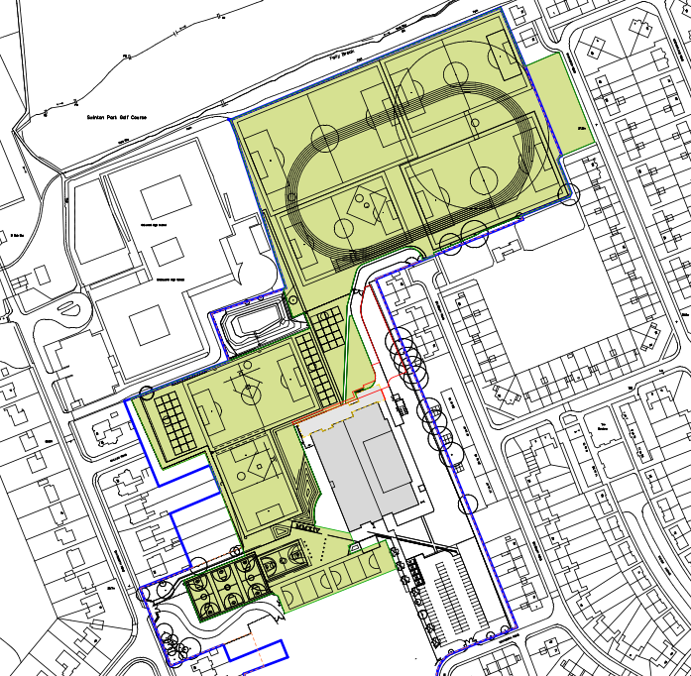

Description of Site and Surrounding Area

This application relates to Ellesmere Park High School, a secondary school located on Wentworth Road in Eccles. The school site comprises the school building, a series of sports pitches and areas of car parking.

The school is located within a mixed-use area being bounded by open land, other educational establishments and residential properties. The image below shows the site and its surroundings –

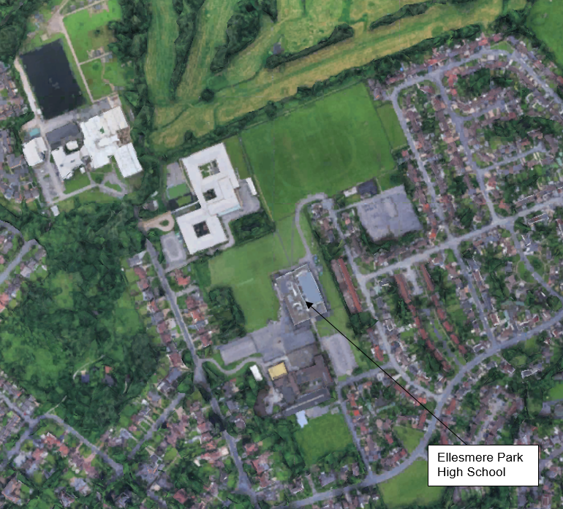

Description of Proposal

The school is in the process of extending, with a lawful development certificate for a part single, part three storey extension to the existing school building having been granted in March 2025 – application reference PA/2025/0170.

The single storey element, which was built at the time of a site visit on the 2 February, is accessed via a sets of steps and/or a new access ramp, with a new footpath also having been installed to the front of the extension. This application seeks to retain these elements, as well as two disabled parking bays and an associated turning circle that have also been installed to the east.

Permission is also sought to further extend the footpath so that it runs to the front of the three storey extension.

The images below show the proposed site layout, and the site as it was on the 2 February -

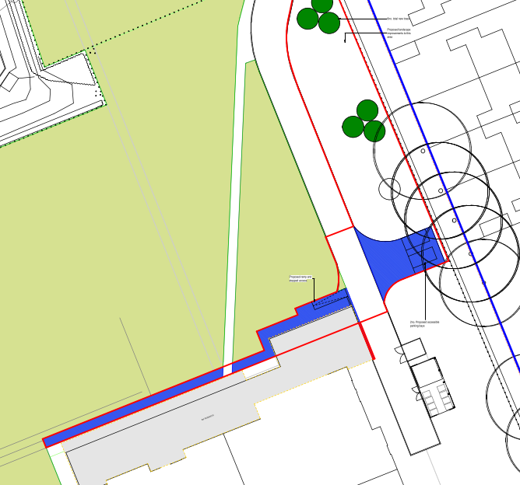
Proposed site plan#

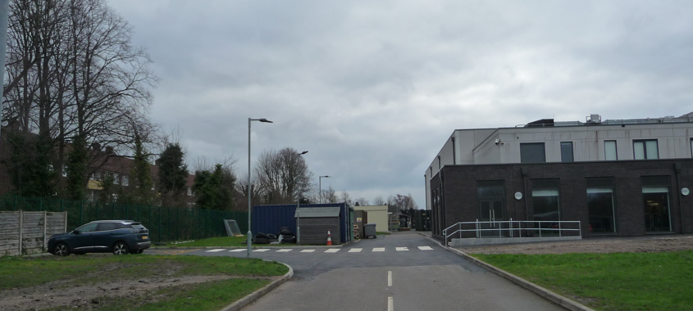

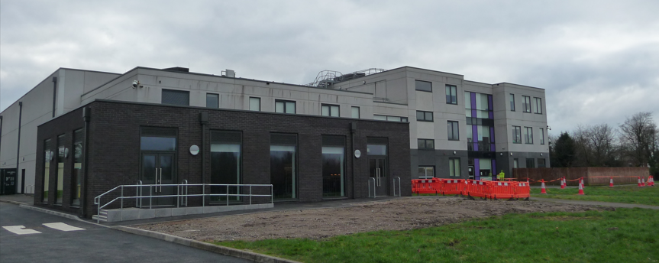

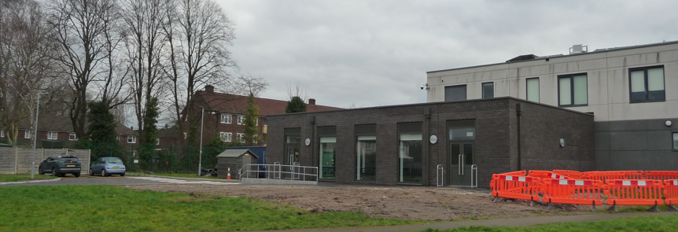
Site photos

Relevant Planning History

Planning Applications
PA/2025/0446 - Lawful development: Proposed use
Decision: Approve - Sent: 20 May 2025
Ellesmere Park High School, Wentworth Road, Eccles, Manchester, M30 9BP
Application for a lawful development certificate for proposed erection of a single-storey classroom block within school site
PA/2025/0170 - Lawful development: Proposed use
Decision: Approve - Sent: 21 March 2025
Ellesmere Park High School, Wentworth Road, Eccles, Manchester, M30 9BP
Application for a lawful development certificate for a proposed part one, part three storey extension to existing secondary school building.
13/63065/FUL - Full planning permission
Decision: Approve - Sent: 2 May 2013
Wentworth High School, Wentworth Road, Eccles, M30 9BP
Erection of a replacement secondary school with associated outdoor sports provision, parking access and landscaping
12/62680/FUL - Full planning permission
Decision: Withdrawn - Sent: 25 March 2013
Wentworth High School , Wentworth Road, Eccles, M30 9BP
Erection of a replacement secondary school with associated outdoor sports provision, parking access and landscaping
Publicity

Site Notice - Publicity Start Date - 2 February 2026

Neighbour Notification

Neighbouring properties have been notified of the application via letter.
The number of neighbouring properties notified - 18

Representations from neighbours and members of the public
Comments of Support - 0
Comments of Objection - 0
Other Representations - 0

Consultations
Greater Manchester Ecology Unit (GMEU)

Advise that the proposal does not raise any ecological issues, with the site having limited ecological value and not providing any cover for wildlife.

In respect of biodiversity net gain they advise that the development will result in the loss of low value grassland, with over 25sqm being lost. As such they advise that the development is subject to mandatory net gain, with the statutory biodiversity gain condition applying.

Confirm that the proposal to plant 6 trees will provide the required 10% gain on site, stating that a 30 year habitat management and monitoring plan, HMMP, will be required. Advise that the HMMP can be secured via a standard condition, rather than through a legal agreement.

Salford Environment Officer
Advise that they have no objections or observations with respect to air quality, noise or land contamination.
Salford Highways Officer
Note that the extension being built using permitted development rights has resulted in the loss of one disabled bay, with the scheme therefore resulting in a net gain of one disabled space. Advise that while the total number of parking spaces at the school site is not known, the addition of one space is unlikely to result in a noticeable increase in trips to and from the site.

Note that the disabled parking bays have not been laid out in a conventional way, with a safety zone to the rear, however given that the bays have already been marked out on site, with the spaces being located in an area with minimal traffic, they advise that the spaces can be retained in their current form.

Confirm that they are happy with the proposed turning head, which provides adequate space for a service vehicle of up to 10.2m in length to manoeuvre at the site.

Conclude that they therefore have no objection to the proposal on highway safety grounds.

Sport England

Confirm that they have no objections to the proposal, stating that the scheme broadly meets exception E3 of their playing fields policy in that 'The proposed development affects only land incapable of forming part of a playing pitch and does not:
- reduce the size of any playing pitch;
- result in the inability to use any playing pitch (including the maintenance of adequate safety margins and run-off areas);
- reduce the sporting capacity of the playing field to accommodate playing pitches or the capability to rotate or reposition playing pitches to maintain their quality;
- result in the loss of other sporting provision or ancillary facilities on the site; or
- prejudice the use of any remaining areas of playing field on the site”.

Planning Policy

Salford Local Plan: Development Management Policies and Designations (SLP:DMP)
Policy F1 An inclusive development process
Policy F2 Social value and inclusion
Policy F3 Inclusive places
Policy F4 Fairness between generations
Policy CC1 Climate change
Policy EF1 Efficient use of land
Policy PC1 Planning conditions and obligations
Policy ED1 Early years, schools and post-16 education facilities
Policy HH1 Development and Health
Policy A1 Supporting sustainable transport
Policy A2 Transport hierarchy and sustainable streets
Policy A3 Walking and cycling
Policy A6 Highway network
Policy A7 Motor vehicle parking provision and drop-off facilities in new developments
Policy A11 Barton Aerodrome
Policy A12 Protection of aviation safety at Manchester Airport
Policy DG2 Protecting digital infrastructure
Policy EG1 Sustainable energy
Policy WA1 Delivering the North West River Basin Management Plan
Policy WA2 Water supply and water efficiency
Policy WA4 Development and flood risk
Policy WA5 Surface water and sustainable drainage
Policy D1 Design principles
Policy D2 Local character and distinctiveness
Policy D3 Layout and access
Policy D4 Spaces
Policy D5 Amenity
Policy D6 Design and crime
Policy D8 Alterations and extensions
Policy GI1 Development and green infrastructure
Policy GI5 Trees, woodland and hedgerows
Policy BG2 Development and biodiversity
Policy R3 Protection of recreation land and facilities
Policy PH1 Pollution control
Policy WM1 Waste and development

Places for Everyone (PfE)
Policy JP-S1: Sustainable Development
Policy JP-S2: Carbon and Energy
Policy JP-S4: Flood Risk and the Water Environment
Policy JP-S5: Clean Air
Policy JP-G7: Trees and Woodland
Policy JP-G8: A Net Enhancement of Biodiversity and Geodiversity
Policy JP-P1 Sustainable Places
Policy JP-C8 Transport Requirements of New Development
Policy JP-P5 Education, Skills and Knowledge
Policy JP-P7: Sport and Recreation

Other Material Planning Considerations

National
National Planning Policy Framework
National Planning Practice Guidance

Local Finance Considerations
It is not considered that there are any local finance considerations that are material to the application.

Appraisal

Principle

The proposal would provide improved facilities at an existing high school site, with the proposal therefore being in accordance with the thrust of national and local planning policy to prioritise the provision and improvement of education facilities.

It would not encroach onto any sports pitches or lead to an inability to mark out pitches for sport, with Sport England having confirmed that they have no objections to the proposal on the basis that it meets exception E3 of their playing fields policy.

The principle of the development is therefore accepted.

Visual Amenity

The proposed works are minor in nature, with the design and appearance of the proposed footpaths, access ramp, parking spaces and turning head being products of their function. Having regard to this, the fact such features are commonly found at school sites and given the limited visibility of the new elements from public vantage points it is not considered that the proposal raises any visual amenity issues.

Trees

There are a number of trees located adjacent to the application site, in the rear gardens of the properties on Salisbury Road. The application has therefore been submitted with a tree survey, arboricultural impact assessment (AIA) and arboricultural method statement (AMS), which have been reviewed by the Council’s consultant arborist.

The arborist has confirmed that no trees would be removed to facilitate the development, stating that the development would not have an adverse effect on the retained trees subject to it being undertaken in accordance with the submitted arboricultural method statement, which details how the existing boundary fence would provide a suitable exclusion zone. They recommend that a condition is attached to this effect.

The works to create the new parking bays and turning circle, which are the elements of the development located within close proximity to the trees in the rear gardens of the units on Salisbury Road, have already been undertaken, with the boundary fence identified in the submitted AMS as protecting the trees from construction, remaining in situ.

It is therefore considered that the development undertaken to date took place in accordance with the details of the AMS, with it not therefore having any adverse impact on the treescape of the area as all adjoining trees remain in situ, and appear healthy, as shown in the images below –

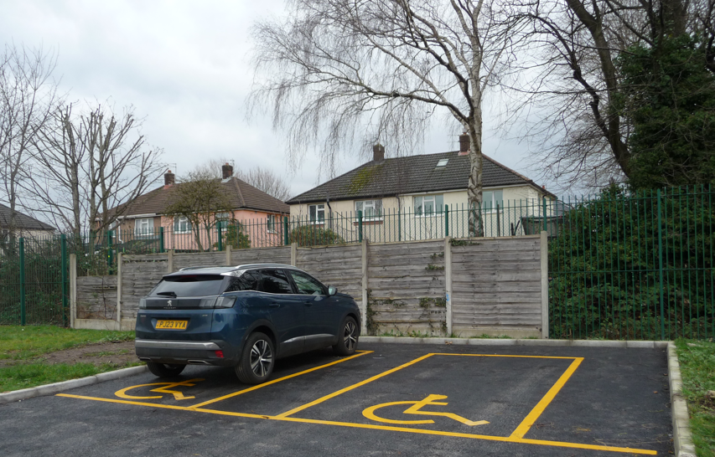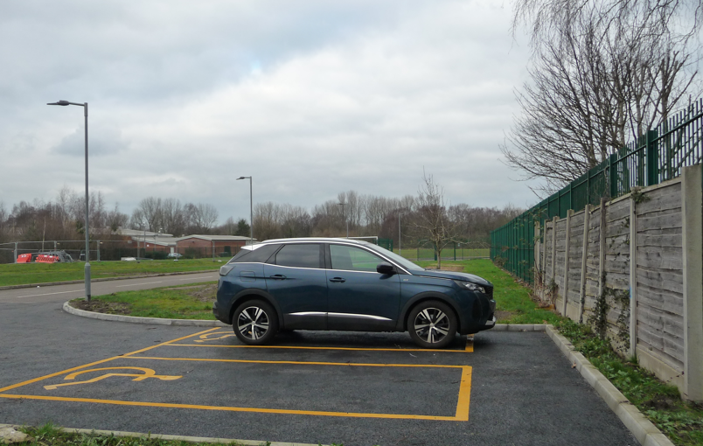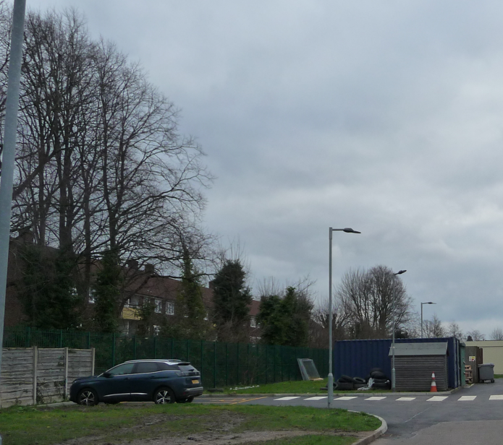

The section of footpath yet to be installed is set at a significant distance from the trees and therefore it is not considered necessary to attach a condition that requires the remainder of the development to be undertaken in accordance with the submitted AMS.

Residential Amenity

Having regard to the low lying nature of the footpath, parking spaces and turning head, the existing boundary treatments and vegetation and the offset that exists between the ramp and the neighbouring residential properties it is not considered that the proposal has/would result in neighbouring residents experiencing any unacceptable loss of light, privacy and/or overbearing impact.

Further the proposal would not in itself increase staff or pupil numbers, with it not therefore intensifying the use of the school site. As such it is not considered that the proposal has/would result in neighbouring residents experiencing any unacceptable increase in the levels of noise and disturbance they are exposed to, with the environment team not raising any objections on noise grounds.

Highway safety

The proposed works have/will not alter the vehicular access to and from the site, with them only resulting in a net increase of one disabled bay meaning the proposal would not result in a noticeable increase in trips to and from the site.

The disabled bays have already been laid out on site, with them not having an identified safety zone at the rear as per a standard disabled space. However they sit in an isolated location, not forming part of a wider car park or an area where the area immediately to the rear of the spaces would likely become obstructed, with the agent having advised that “the parking spaces are an additional bonus for the school and are intended to be used as a means of a drop off for SEND pupils, rather than be parked in throughout the day, so the risks of cars being in these spaces when other delivery/servicing vehicles are in place is low as they would not be used outside of school drop-off/pick-up times when deliveries would be avoided”. Consequently the bays would be able to function as disabled bays even without the standard markings and as such their layout is considered acceptable in this instance.

Having regard to this and given that the proposed turning head is suitably designed, it is not considered that the proposal would have any unacceptable adverse impact upon the local highway network, with the Council’s highway officer not having raised any objections.

Ecology

The application has been reviewed by the Greater Manchester Ecological Unit (GMEU) who have advised that they have no objections to the proposal on ecological grounds, with the site having limited ecological value and not providing any cover for wildlife.

In respect of biodiversity net gain Local Plan Policy BG2 requires minor development such as this to provide a net gain in biodiversity, with policy JP-G8 of Places for Everyone requiring all development to provide a measurable net gain in biodiversity of no less than 10%. Building upon local and national policy, the mandatory legislation associated with the Environment Act now applies to small and large developments in the UK, requiring them to measurably increase the biodiversity of a site by 10% unless exempt.

The application has been submitted with a biodiversity net gain assessment and metric. These have been reviewed by GMEU, who have confirmed that the submitted documents demonstrate that more than 25sqm of vegetated habitat will be lost as a result of the development, with a 10% net gain in biodiversity being capable of being provided on site via the planting of 6 trees. Since the gain is considered significant, GMEU have advised that a 30 year habitat management and monitoring plan will be required, with them stating that this should be secured via the attachment of a suitably worded condition.

Since GMEU commented on the application it has become apparent that the majority of works have already been undertaken on site, with the application being retrospective. Retrospective applications are not subject to mandatory net gain.

Notwithstanding this, in line with the Local Plan policy BG2 and PFE policy JP-G8, a suitably worded condition will be attached to secure the proposed tree planting, thereby ensuring a 10% gain in biodiversity is provided as per the requirements of the development plan. The condition will be drafted to secure suitable replanting should the any of the trees be removed, uprooted, destroyed, die or become severely damaged or become seriously diseased within 30 years of planting.

Recommendation

Approve with conditions.

Document Approval
Report Author | Nancy Thynne
Date | 3.3.26
Reviewer | A Stephenson
Date | 3.3.26

